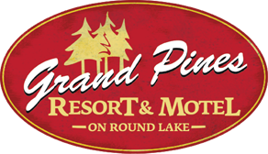

Meetings and Events

Welcome to Grand Pines Resort nestled on over 1,500 ft. of frontage on stunning Big and Little Round Lakes in world-renowned Hayward, WI! We comprise of approximately 2,500 sq. ft. of meeting and event space divided between two separate locations, and can accommodate groups of 10 to 150. Patrons benefit from our lodging collection, 20 Northwood’s-Themed Cabins and 10 Motel rooms, as they can provide the ideal match for individual needs and budgets...an event here is a true “up north” occasion!

Famous Dave’s Conference Center

Standalone building located in the Northeast corner of the Resort’s main parking lot, this space features two separate rooms, as well as a built in bar.
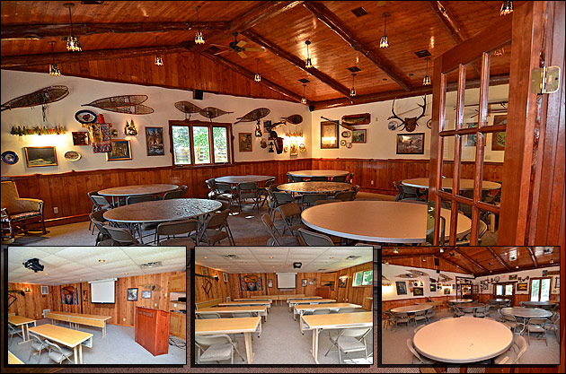

Majestic Pines – Main Entry Room
  - Room Size – 750 sq. ft.
  - Setup Styles – Banquet (8 people per table), Classroom (long, thin tables for 3 people), Theater (chairs only), Boardroom and U-Shape

Royal Oaks – Side Room
  - Room Size – 868 sq. ft.
  - Setup Styles – Banquet (8 people per table), Classroom (long, thin tables for 3 people), Theater (chairs only), Boardroom and U-Shape

Features
  - Built-in screen and ceiling projector located in Royal Oaks
  - Restrooms, men and women, located in between both rooms
  - Catering services must be provided by a licensed caterer
    - Your Grand Pines contact can help coordinate
  - Parking available in the Resort main parking lot

Rates
  - Full Day - $200 for both rooms or $150 for one room
  - Half Day - $100 for both rooms or $75 for one room (maximum of 4 hours)

Included
  - Access to space one hour prior to beginning of event to setup, and one hour after event to tear down
  - Table and chairs will be setup as requested
  - AV equipment setup as predetermined

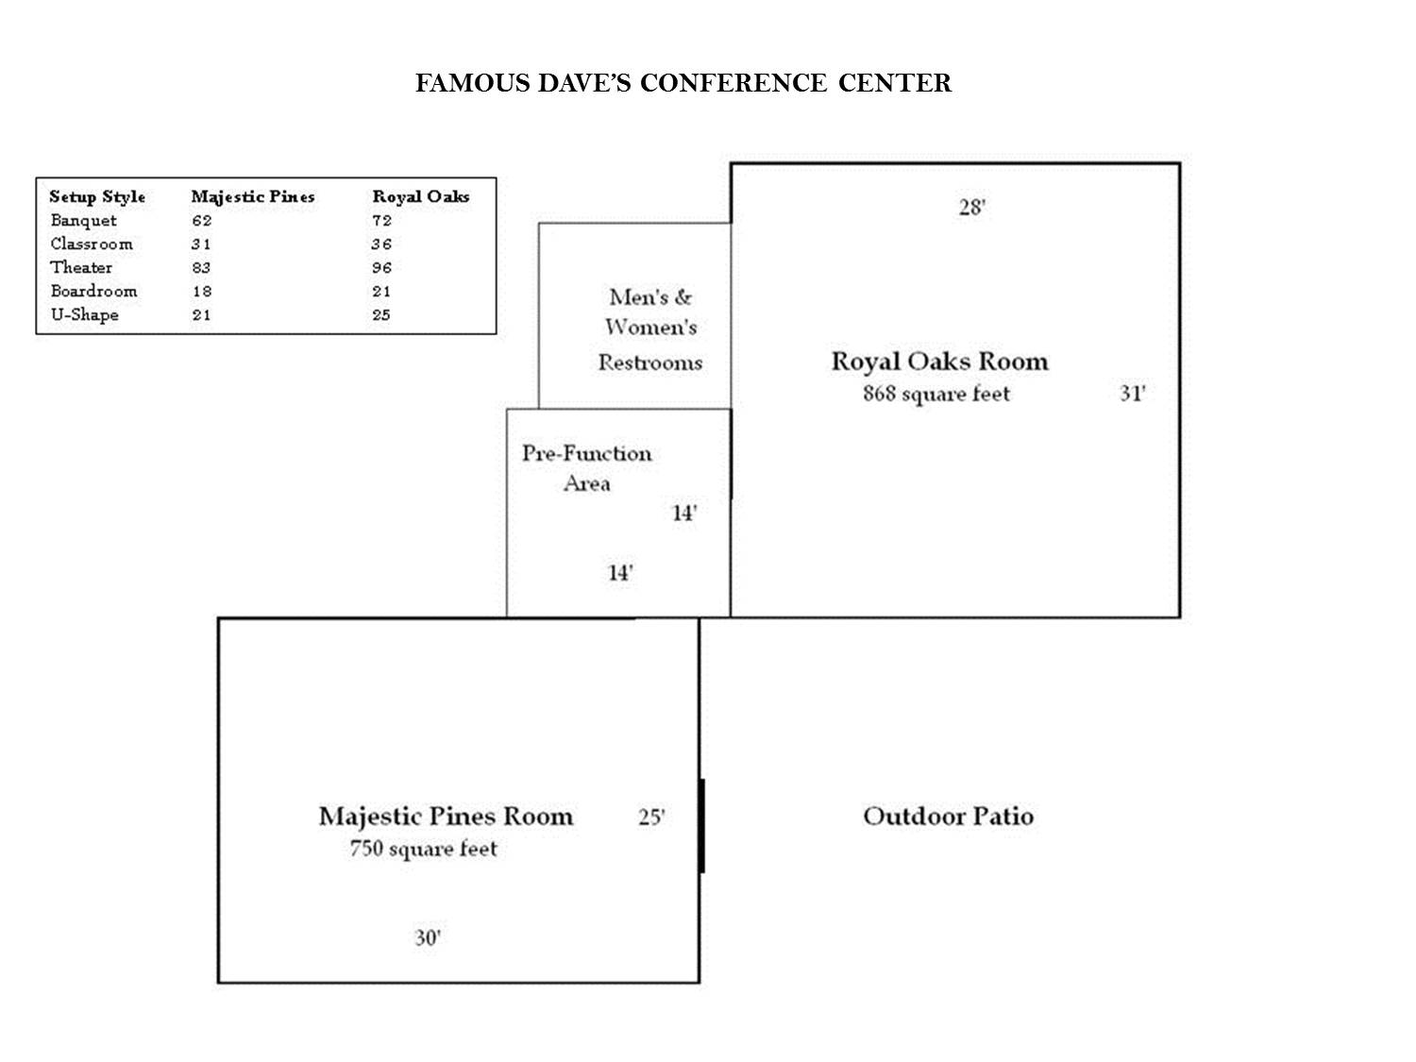

Grand Pines Motel – Whispering Pines

Connected to our 10-room Motel on Little Round Lake, the open floor plan makes the space desirable for many different functions.
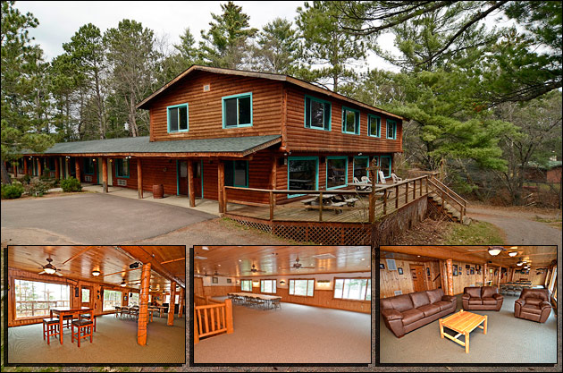

Whispering Pines Lower (Main)
  - Room Size – 936 sq. ft.
  - Setup Styles – Rectangular banquet tables
    - We only have tables and chairs for up to 50 people, the space can accommodate more, you are welcome to bring in additional seating

Features
  - Catering Kitchen, includes
    - Refrigerator
    - Stove/Oven
    - Microwave
    - Coffee Maker
  - Large Deck Outside
  - Restrooms – Men and Women

Rates
  - Full Day - $100
  - Half Day - $75 (maximum of 4 hours)

Included
  - Access to space one hour prior to beginning of event to setup, and one hour after event to tear down
  - Table and chairs (arranged as predetermined)
    - Any other equipment would need to be brought in and setup by client
  - Use of Catering Kitchen (if renting both levels, or the main level only)
    - Client responsible for catering services, catering services must be provided by a licensed caterer, your Grand Pines contact can help coordinate
  - Parking available at Motel

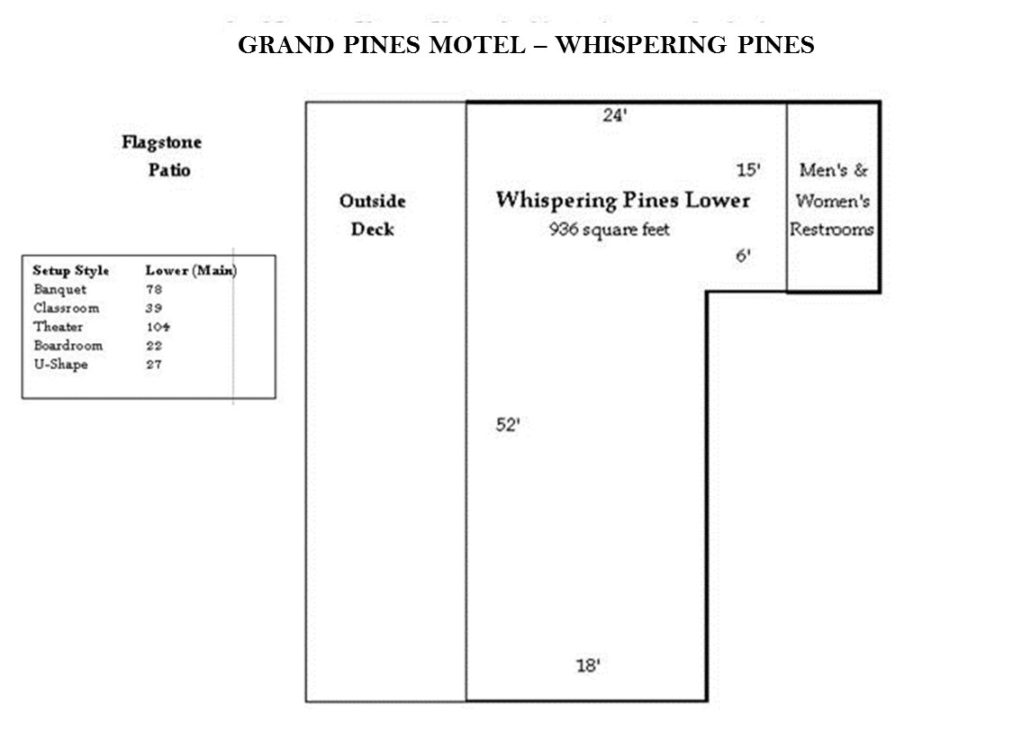

Grand Pines Resort Lodging is available for groups at a discounted rate during certain times of the year. Please contact our Grand Pines Group Representative about your event today!

Looking for some additional activities for your group…we can accommodate that for you as well. We look forward to working with you and your group! Contact us at 715-462-4006 or grandpinesgroups@gmail.com.

